THE
HEFFERNAN
GROUP

Student Name……… Student Name……………………………………

PO Box 480

Deepdene Delivery Centre 3103

Phone/Fax 9836 5025

ABN 20 607 374 020

SPECIALIST MATHEMATICS

TRIAL EXAMINATION 2

(ANALYSIS TASK)

2001

Reading Time: 15 minutes
Writing time: 90 minutes

Instructions to students
This exam consists of 6 questions.
All questions should be answered.
There is a total of 60 marks available.
The marks allocated to each of the six questions are indicated throughout.
Students may bring up to two A4 pages of pre-written notes into the exam.
The acceleration due to gravity should be taken to have magnitude 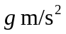where 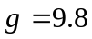
Formula sheets can be found on pages 16-18 of this exam.

This paper has been prepared independently of the Victorian Curriculum and Assessment Authority to provide additional exam preparation for students. Although references have been reproduced with permission of the Victorian Curriculum and Assessment Authority, the publication is in no way connected with or endorsed by the Victorian Curriculum and Assessment Authority.

© THE HEFFERNAN GROUP 2001
This Trial Exam is licensed on a non transferable basis to the purchaser. It may be copied for educational use within the school which has purchased it. This license does not permit distribution or copying of this Trial Exam outside that school or by any individual purchaser.

Question 1

Consider the function 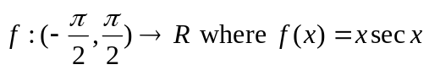.

a. Find the y-intercept of the graph of .

____________________________________________________________________

____________________________________________________________________
1 mark

b. Sketch the graph of on the set of axes below.

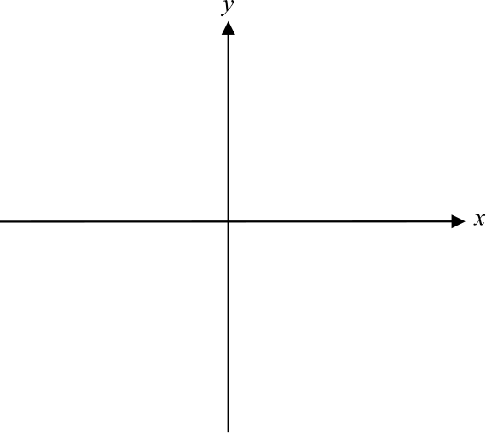

2 marks

c. Find 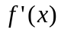

____________________________________________________________________

____________________________________________________________________

____________________________________________________________________

____________________________________________________________________

____________________________________________________________________

____________________________________________________________________
1 mark

d. Explain whether or not the graph of has a stationary point at the point
where .

____________________________________________________________________

____________________________________________________________________

____________________________________________________________________

____________________________________________________________________

____________________________________________________________________
1 mark

e. Use the fact that 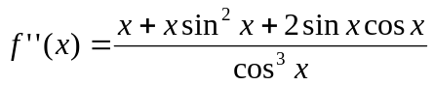 to find the coordinates of the
point on the graph of where the gradient is a minimum.

____________________________________________________________________

____________________________________________________________________

____________________________________________________________________

____________________________________________________________________

____________________________________________________________________

____________________________________________________________________
2 marks

f. Verify that 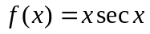 is a solution to the differential equation

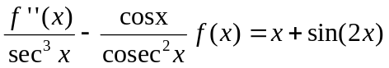

____________________________________________________________________

____________________________________________________________________

____________________________________________________________________

____________________________________________________________________

____________________________________________________________________

____________________________________________________________________

____________________________________________________________________
2 marks

Total 9 marks
Question 2

A crate of mass 20kg rests on a rough inclined plane and is attached to a light, inextensible string that passes over a smooth pulley and is attached to a weight of mass 15kg.
The crate is on the point of moving up the incline. Let be the tension force in the string and let  be the normal force.

a. On the diagram below, mark in the forces acting on the crate and on the weight.

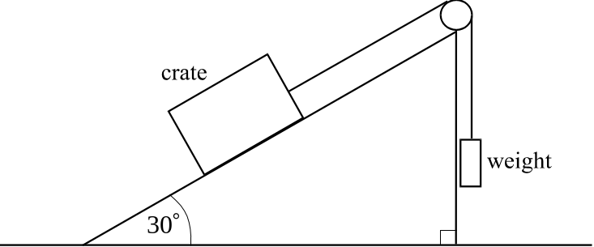

1 mark

b. Find the coefficient of friction between the crate and the plane.

____________________________________________________________________

____________________________________________________________________

____________________________________________________________________

____________________________________________________________________

____________________________________________________________________

____________________________________________________________________

____________________________________________________________________

____________________________________________________________________

____________________________________________________________________

____________________________________________________________________

____________________________________________________________________

____________________________________________________________________
3 marks
A force of 100 Newton acts parallel to the inclined plane and pulls the crate down the slope with the 15 kg weight still attached.

c. Find the acceleration of the 15kg weight. Express your answer correct to 2 decimal places.

____________________________________________________________________

____________________________________________________________________

____________________________________________________________________

____________________________________________________________________

____________________________________________________________________

____________________________________________________________________

____________________________________________________________________

____________________________________________________________________

____________________________________________________________________

____________________________________________________________________

____________________________________________________________________

____________________________________________________________________

____________________________________________________________________

____________________________________________________________________

____________________________________________________________________

____________________________________________________________________
4marks

Total 8 marks

Question 3

Let 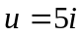.

a. Express in polar form.

____________________________________________________________________

____________________________________________________________________

____________________________________________________________________
1 mark

b. If 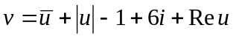, find in Cartesian form.

____________________________________________________________________

____________________________________________________________________

____________________________________________________________________
1 mark

c. If 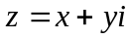, where x and y are real and 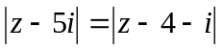, express y in terms of x.

____________________________________________________________________

____________________________________________________________________

____________________________________________________________________

____________________________________________________________________

____________________________________________________________________

____________________________________________________________________

____________________________________________________________________
3 marks
d. Hence or otherwise, sketch on the Argand diagram below, S, where
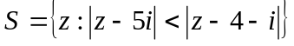 and 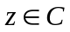. Indicate clearly whether or not the
boundary is included.

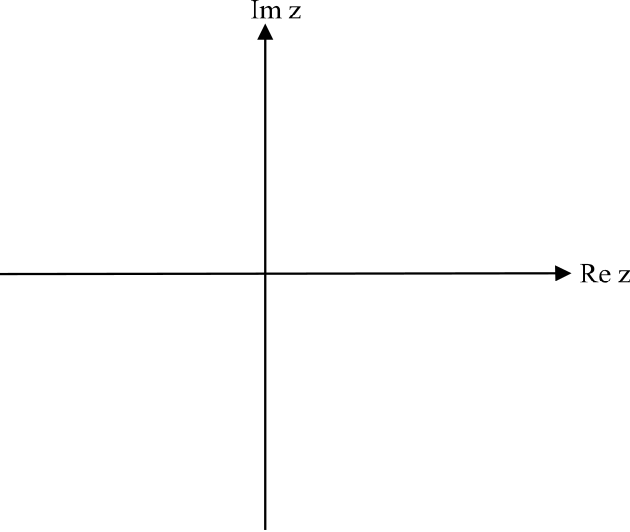

2 marks

e. Write down, in Cartesian form, the cube root(s) of 8 that lie in S.

____________________________________________________________________

____________________________________________________________________

____________________________________________________________________

____________________________________________________________________

____________________________________________________________________

____________________________________________________________________

____________________________________________________________________

____________________________________________________________________

____________________________________________________________________

____________________________________________________________________

____________________________________________________________________

____________________________________________________________________
2 marks

Total 9 marks
Question 4

Consider the function 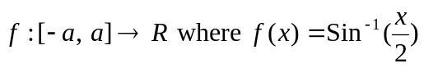.

a. Write down the value of a given that f has a maximal domain.

____________________________________________________________________

____________________________________________________________________
1 mark

b. i. Sketch the graph of on the set of axes below.

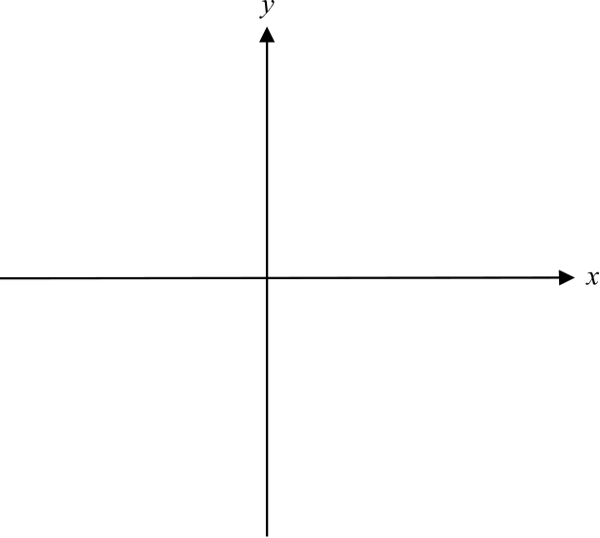

1 mark

ii. Show algebraically that the graph in part i. has no stationary points.

____________________________________________________________________

____________________________________________________________________

____________________________________________________________________

____________________________________________________________________

____________________________________________________________________
2 marks
c. Find 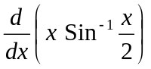

____________________________________________________________________

____________________________________________________________________

____________________________________________________________________

____________________________________________________________________

1 mark
d. i. Hence, use calculus to find an antiderivative of 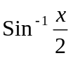.

____________________________________________________________________

____________________________________________________________________

____________________________________________________________________

____________________________________________________________________

____________________________________________________________________

____________________________________________________________________

____________________________________________________________________

____________________________________________________________________

____________________________________________________________________
2 marks

ii. Hence find the area enclosed by the graph of , the x-axis and the
line with equation . Express your answer as an exact value.

____________________________________________________________________

____________________________________________________________________

____________________________________________________________________

____________________________________________________________________

____________________________________________________________________

____________________________________________________________________
2 marks
e. Use calculus to find the volume of the solid of rotation formed when the graph of
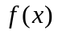 between 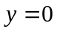 and 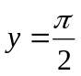, is rotated about the y-axis. Express your answer
as an exact value.

____________________________________________________________________

____________________________________________________________________

____________________________________________________________________

____________________________________________________________________

____________________________________________________________________

____________________________________________________________________

____________________________________________________________________

____________________________________________________________________

____________________________________________________________________

____________________________________________________________________

____________________________________________________________________

____________________________________________________________________

____________________________________________________________________

____________________________________________________________________
3 marks

Total 12 marks
Question 5

A particle moves so that its position vector at time t, 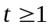, is given by

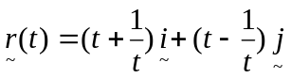

a. Find an expression for the distance from the origin to the particle at time t.

____________________________________________________________________

____________________________________________________________________

____________________________________________________________________

____________________________________________________________________
1 mark

b. Find the speed of the particle at time 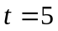.

____________________________________________________________________

____________________________________________________________________

____________________________________________________________________
2 marks

c. i. Find the Cartesian equation of the path of the particle and state the domain
and range.

____________________________________________________________________

____________________________________________________________________

____________________________________________________________________

____________________________________________________________________

____________________________________________________________________

____________________________________________________________________

____________________________________________________________________

____________________________________________________________________

____________________________________________________________________

____________________________________________________________________
4 marks
ii. Sketch the path of the particle on the diagram below.

1 mark

A second particle has a velocity vector given by

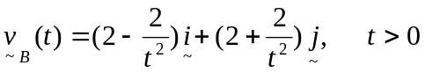

When 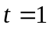, the position vector is given by 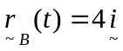.

d. Show that the position vectors of this second particle and of the first particle at time t
are parallel.

____________________________________________________________________

____________________________________________________________________

____________________________________________________________________

____________________________________________________________________

____________________________________________________________________

____________________________________________________________________

____________________________________________________________________
3 marks

Total 11 marks
Question 6

Julie gets onto a straight stretch of a freeway at time and has a velocity in m/s at time t seconds of

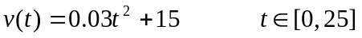

a. What is Julie’s entry speed onto the freeway?

____________________________________________________________________

____________________________________________________________________
1 mark

Julie’s friend Tom is also traveling on the freeway in the same direction as Julie. Tom passes Julie the instant she gets onto the freeway. Tom is travelling at a constant speed of 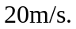

The velocity-time graph for Tom’s travel is shown below.

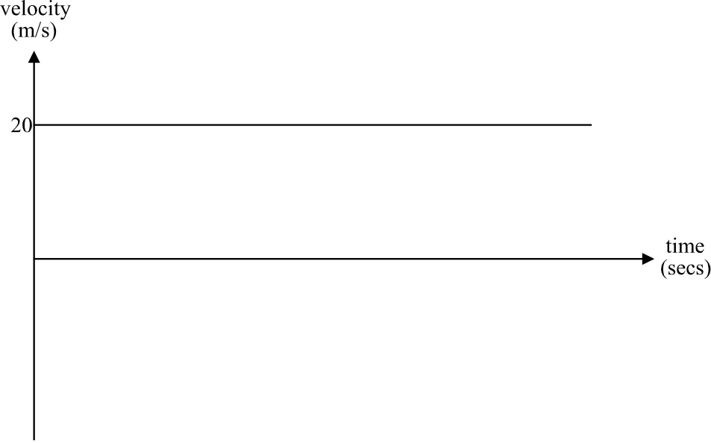

b. Sketch on the same set of axes the velocity-time graph for Julie.
1 mark

c. Find, correct to 2 decimal places, the time when Julie catches up to Tom.

____________________________________________________________________

____________________________________________________________________

____________________________________________________________________

____________________________________________________________________

____________________________________________________________________

____________________________________________________________________

____________________________________________________________________
2 marks

Further down the freeway, Julie spots what she thinks might be a police speed camera. From that point on, her acceleration may be described by the equation

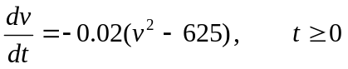

d. i. Solve this differential equation to obtain t in terms of v given that at the start
of this period of acceleration, 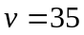.

____________________________________________________________________

____________________________________________________________________

____________________________________________________________________

____________________________________________________________________

____________________________________________________________________

____________________________________________________________________

____________________________________________________________________

____________________________________________________________________

____________________________________________________________________

____________________________________________________________________

____________________________________________________________________

____________________________________________________________________

____________________________________________________________________

____________________________________________________________________
3 marks
ii. Hence show that 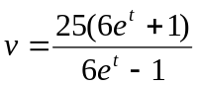

____________________________________________________________________

____________________________________________________________________

____________________________________________________________________

____________________________________________________________________

____________________________________________________________________

____________________________________________________________________

____________________________________________________________________

____________________________________________________________________

____________________________________________________________________

____________________________________________________________________
2 marks

f. If Julie were to maintain this pattern of deceleration, find her limiting velocity.
Explain your answer.

____________________________________________________________________

____________________________________________________________________

____________________________________________________________________

____________________________________________________________________

____________________________________________________________________

____________________________________________________________________

____________________________________________________________________
2 marks

Total 11 marks

Mathematics Formulas
Specialist Mathematics Formulas

Mensuration

area of a trapezium:
curved surface area of a cylinder:
volume of a cylinder:
volume of a cone:
volume of a pyramid:
volume of a sphere:
area of a triangle:
sine rule:
cosine rule:

Coordinate geometry

ellipse:
hyperbola:

Circular (trigonometric) functions

function
domain

range

Reproduced with permission of the Victorian Curriculum and Assessment Authority.

Algebra (Complex numbers)

(de Moivre’s theorem)

Calculus

product rule:
quotient rule:
chain rule:

Reproduced with permission of the Victorian Curriculum and Assessment Authority.

mid-point rule:
trapezoidal rule:
Euler’s method:

acceleration:
constant (uniform) acceleration:

Vectors in two and three dimensions

Mechanics

momentum:
equation of motion:
friction:

Reproduced with permission of the Victorian Curriculum and Assessment Authority.
(Taken from Issue 156 of the Bulletin.)

